**EXPERIMENT NO. 10**

**NAME:** Arya Manoj Madhavi

**CLASS:** D15B

**ROLL NO.:** 31

**AIM:** To perform Port, Service monitoring, Windows/Linux server monitoring using Nagios.

**Output-**

**Prerequisites**

● AWS Free Tier

● Nagios Server running on an Amazon Linux Machine

**1.** **Confirm Nagios is Running on the Server**

● sudo systemctl status nagios

● Proceed if you see that Nagios is active and running.

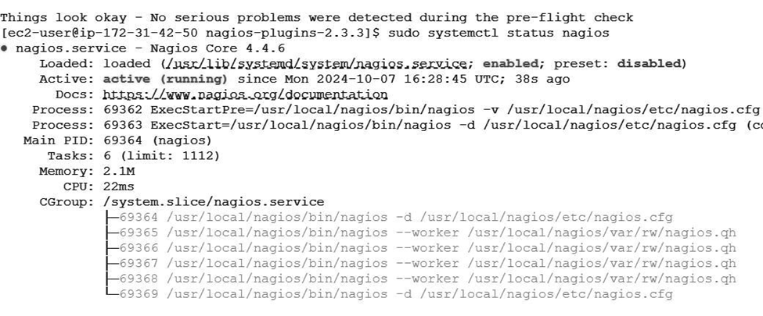

**2.** **Create an Ubuntu 20.04 Server EC2 Instance** ● Name it linux-client.

● Use the same security group as the Nagios Host

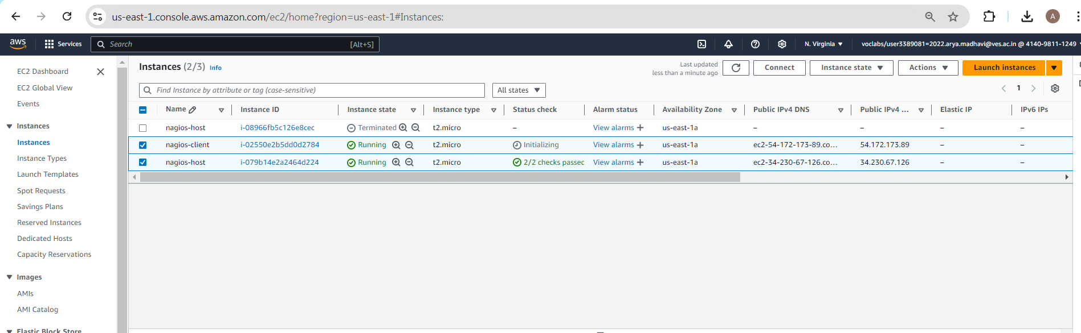

**3.** **Verify Nagios Process on the Server**

Commands

● - ps -ef | grep nagios

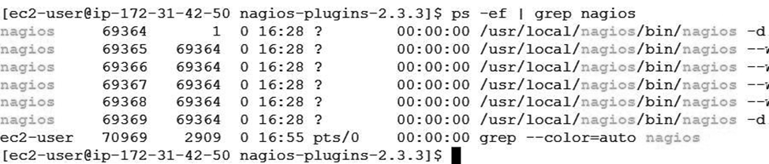

**4.** **Become Root User and Create**

**Directories** sudo su

● mkdir -p /usr/local/nagios/etc/objects/monitorhosts/linuxhosts



**5.** **Copy Sample Configuration File**

cp /usr/local/nagios/etc/objects/localhost.cfg

/usr/local/nagios/etc/objects/monitorhosts/linuxhosts/linuxserver.cfg



**6.** **Edit the Configuration File** sudo nano /usr/local/nagios/etc/objects/monitorhosts/linuxhosts/linuxserver.cfg ● Change hostname to linuxserver everywhere in the file.

● Change address to the public IP address of your linux-client.

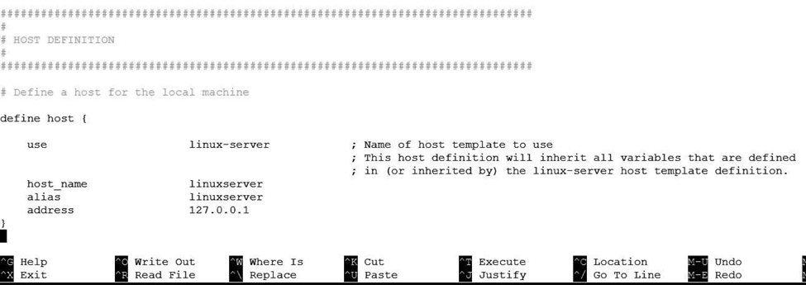

**7. Update Nagios Configuration** sudo nano /usr/local/nagios/etc/nagios.cfg

● Add the following line: cfg_dir=/usr/local/nagios/etc/objects/monitorhosts/

● Change hostgroup_name under hostgroup to linux-servers1

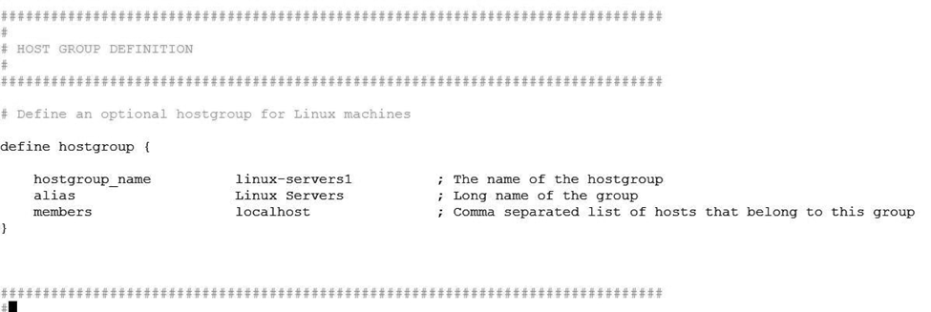

**8.** **Verify Configuration Files** sudo /usr/local/nagios/bin/nagios -v /usr/local/nagios/etc/nagios.cfg

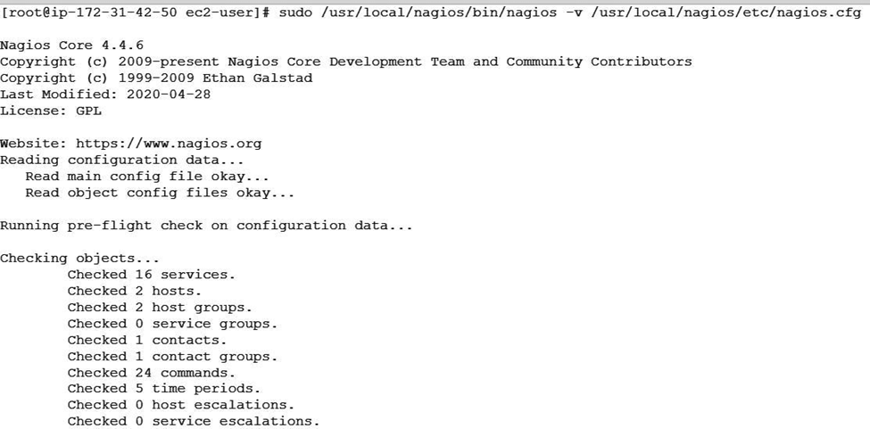

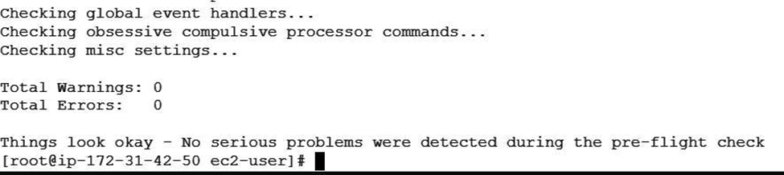

**9.** **Restart Nagios Service**

● sudo systemctl restart nagios

**10.** **SSH into the Client Machine**

● Use SSH or EC2 Instance Connect to access the linux-client.

**11. Update Package Index and Install Required Packages**

● sudo apt update -y

● sudo apt install gcc -y

● sudo apt install -y nagios-nrpe-server nagios-plugins

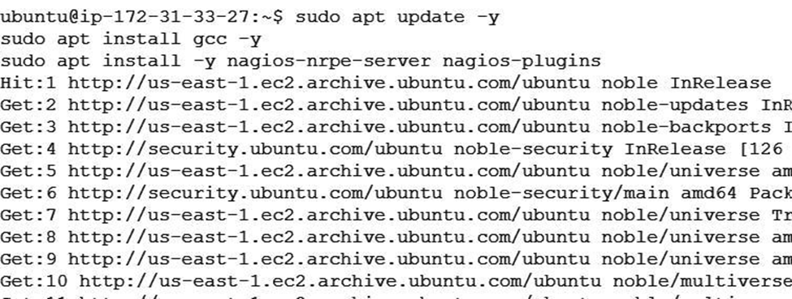

**12. Edit NRPE Configuration File** Commands -

sudo nano /etc/nagios/nrpe.cfg

● Add your Nagios host IP address under allowed_hosts: allowed_hosts=

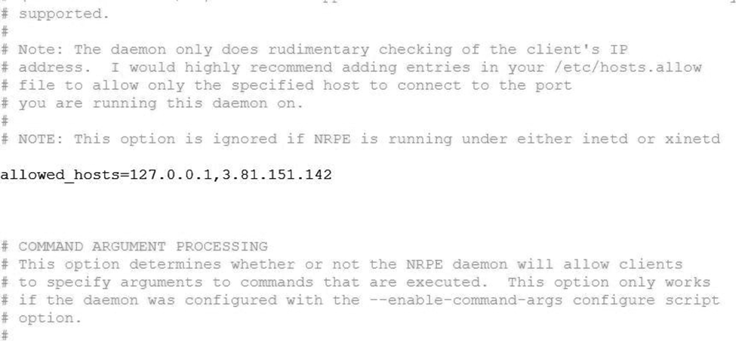

**14. Check Nagios Dashboard**

● Open your browser and navigate to http:///nagios.

● Log in with nagiosadmin and the password you set earlier.

● You should see the new host linuxserver added.

● Click on Hosts to see the host details.

● Click on Services to see all services and ports being monitored

